15.48: a) From comparison with Eq.
b)
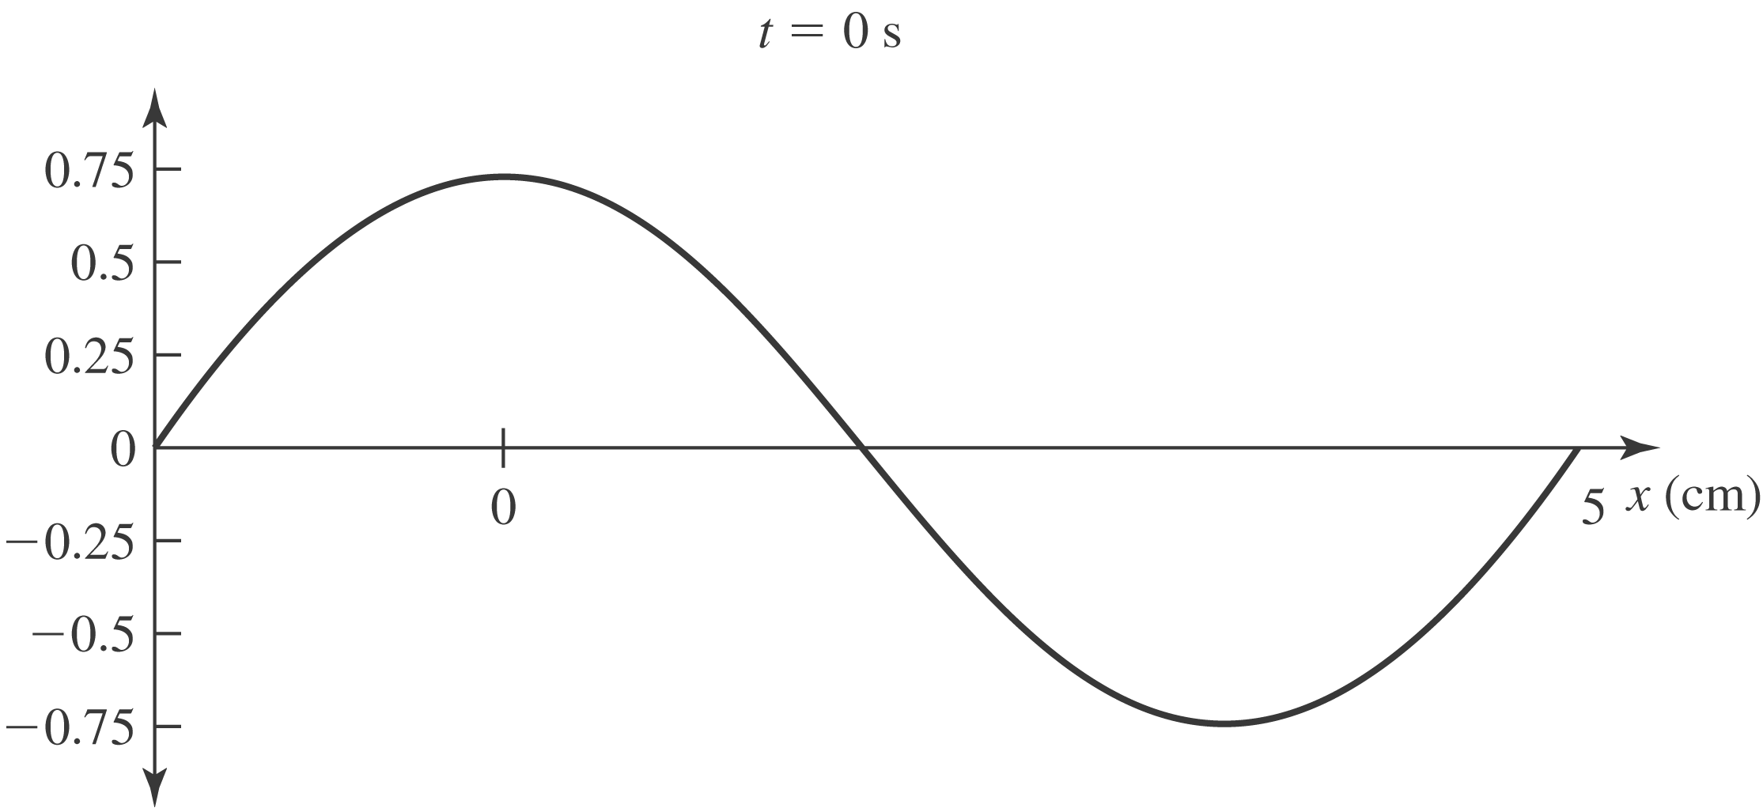

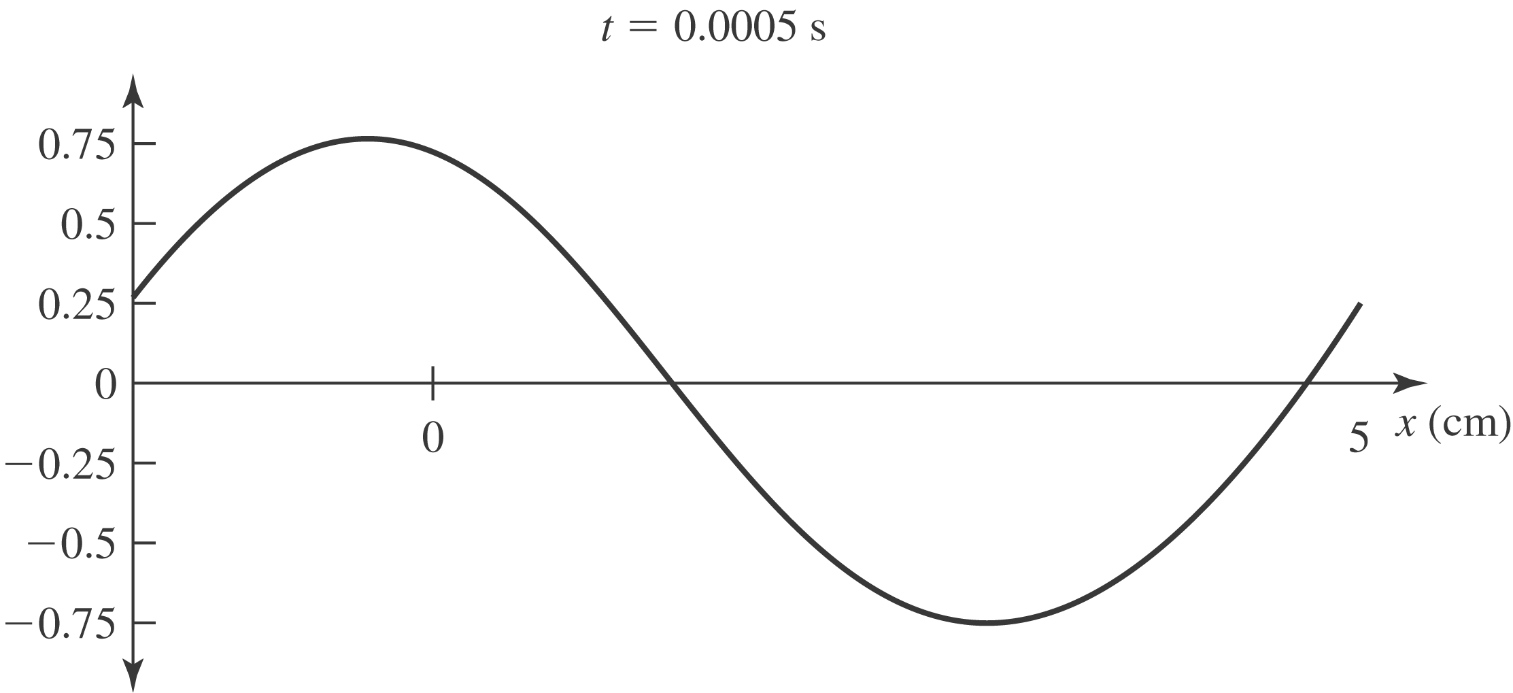

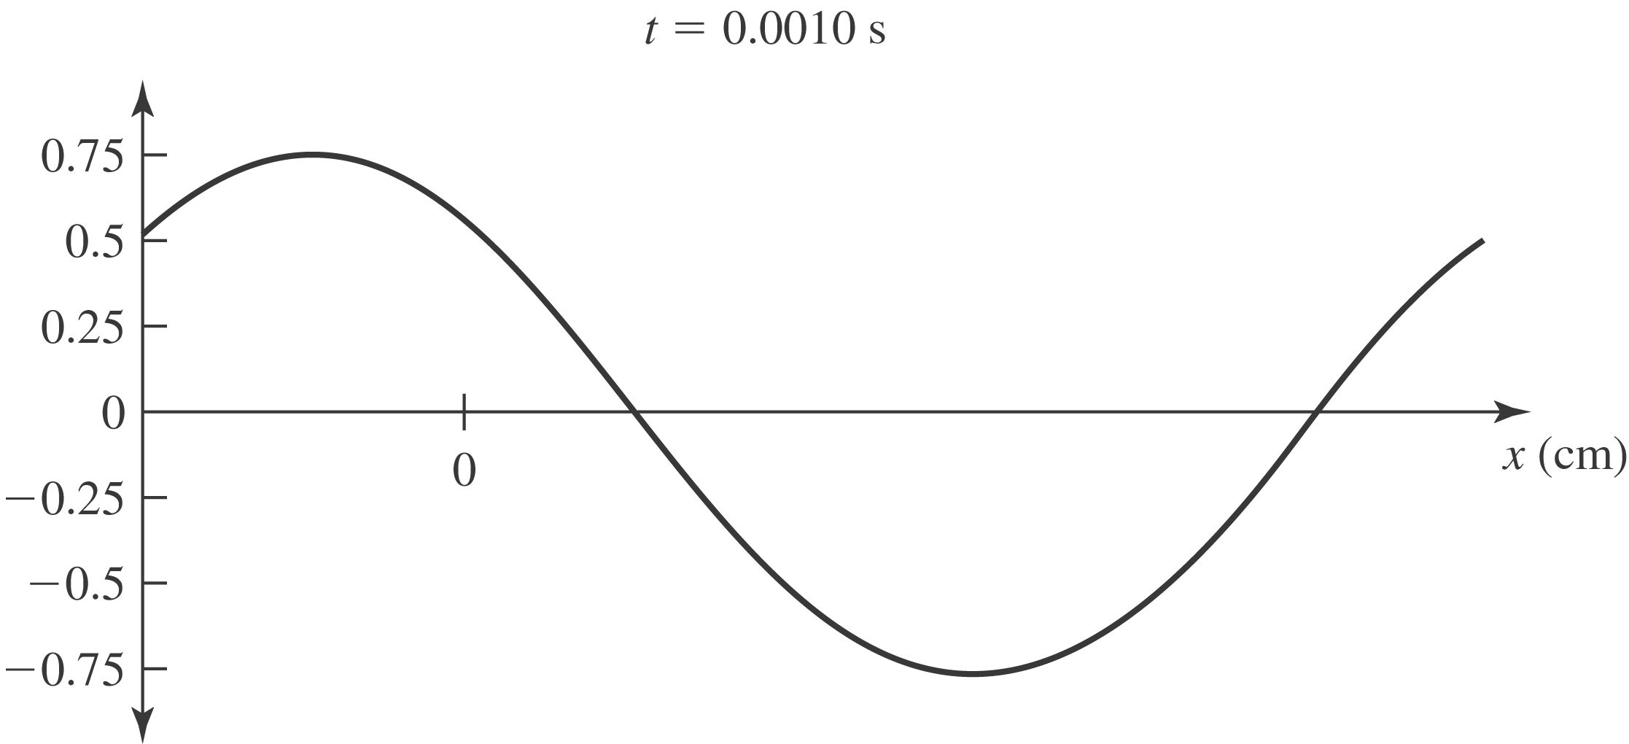

c) To stay with a wavefront as increases, and so the wave is moving in the - direction. d) From Eq.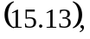the tension is

e) 